Introduction

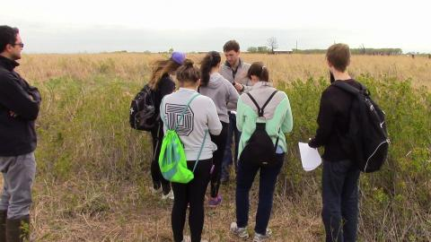
Major Themes for the Unit
- Scientific themes: Ecological Interactions, Climate Change, Nutrient Cycling, Energy Flow, Biodiversity
- Scientific practice: modeling, argumentation
- SSI: Climate change and its effect on ecosystems
Driving Question: How might climate change affect the complex interactions in local ecosystems?
Concepts needed to explore the driving question
- Science concepts
  - Carbon Cycling
  - Photosynthesis
  - Relationship Between Photosynthesis and Cellular Respiration
  - Ecological Interactions
  - Energy Flow
- What social ideas and concerns influence negotiation of the issue?
  - Economics
  - Politics
  - Energy Production and Consumption
  - Alternative Energy Sources
Unit-level performance expectations
- Use an ecosystem model to make predictions regarding the stability/change of populations within a particular ecosystem in response to climatic changes. Engage in argumentation about the relative stability/change of an ecosystem (NGSS HS-LS2-6).
- Develop and use multiple models, some of which include mathematical representations, to explain the cycling of matter and flow of energy among organisms in an ecosystem (NGSS HS-LS2-2, HS-LS2-4).
- Obtain, evaluate and communicate information about a specific climate change impact. Engage in argumentation regarding appropriate responses to this situation (NGSS HS-LS2-7).
- Develop a qualitative model of the inputs and outputs of photosynthesis that accounts for/predicts impacts of climatic changes (NGSS HS-LS1-5).
- Develop a qualitative model of the inputs and outputs of cellular respiration that accounts for the cycling of matter and transfer of energy (NGSS HS-LS1-7, HS-LS2-5).
- Develop a model to illustrate the role of photosynthesis and cellular respiration in the cycling of carbon among the biosphere, atmosphere, hydrosphere, and geosphere (NGSS HS-LS2-5).
Instructional Sequences
Assessments
- Practice quizzes- two short quizzes throughout the unit
- Models- Photosynthesis and Carbon cycling models produced throughout the unit
- Culminating Project- model and explanation to make sense of the likely impacts of climate change on an organism from another part of the world
- Unit Test- 25 multiple choice and short answer questions
Acknowledgments
The materials associated with the Vanishing Prairie Unit are based upon work supported by The Missouri Transect, a National Science Foundation EPSCoR Program, Cooperative Agreement IIA-1355406. Any opinions, findings, and conclusions or recommendations expressed in this material are those of the author(s) and do not necessarily reflect the views of the National Science Foundation.

