Introduction
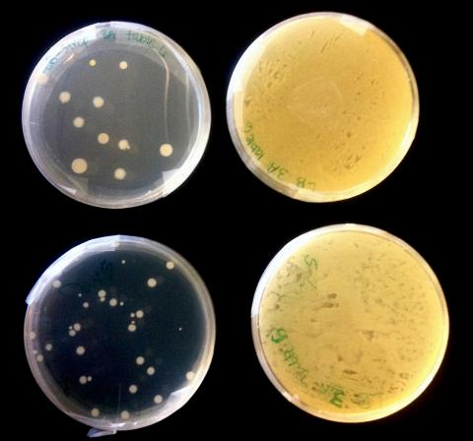
Issue: Evolution of Antibiotic Resistant Bacteria
Content Focus: Natural Selection
Level: High School
Classes: Honors Biology
Focal Points of the Unit:
- Developing and using a conceptual model of biological evolution.
- Exploring the scientific and social dimensions of an evolution-related socio-scientific issue (SSI)
Student Learning Objectives
As a result of learning experiences in the unit, students will be able to:
- Develop and explain a conceptual model of natural selection that accounts for a) genetic variation associated with particular traits, b) selective pressure that leads to differential reproductive success linked to these traits, and c) changes in trait frequencies within the population.
- Use the model (1) as a basis for reasoning about novel problem situations.
- Create and describe a representation of a cellular mechanism that confers bacterial resistance to antibiotics. (Elements of this representation should include targets of antibiotic activity and ways in which bacteria disrupt that activity.)
- Demonstrate socio-scientific reasoning in response to complex SSI.
  - Identify and discuss sources of issue complexity.
  - Identify areas of uncertainty and ask related questions.
  - Analyze the issue from multiple perspectives.
  - Identify and discuss ways in which scientific evidence can inform issue resolution as well as limits on the use of scientific evidence.
Instructional Sequence
Assessments
- Models of cellular mechanisms and related changes in bacterial populations (multiple time points) – Formative
- Models of natural selection in the context of the laboratory investigation – Formative
- Application of NS model to a novel case – Formative & Summative
- Application of Socio-scientific Reasoning in the context of a policy recommendation - Formative & Summative
- Natural Selection Test; multiple choice (CINS) plus open-ended item (Opfer, Nehm & Ha, 2012) – Summative
Acknowledgments
The materials associated with the Superbugs Unit are based, in part, upon work supported by the National Science Foundation Transforming Undergraduate Education in Science (TUES) program under Grant 114062 and The Missouri Transect, a National Science Foundation EPSCoR Program, Cooperative Agreement IIA-1355406. Any opinions, findings, and conclusions or recommendations expressed in this material are those of the author(s) and do not necessarily reflect the views of the National Science Foundation. The materials presented in Lesson 7. Mountain Sheep Model were created by the PRACCIS team is copyrighted, 2014, by the PRACCIS project team (Clark Chinn and Ravit Golan Duncan, Project Directors). All rights are reserved.

