Introduction
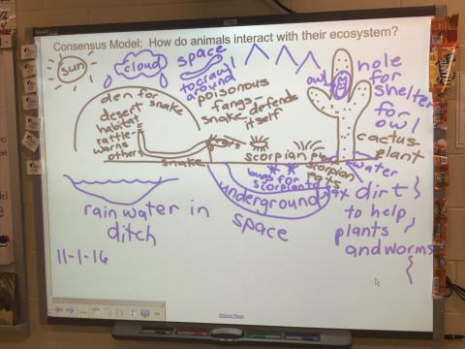
Major Themes for the Unit
- Scientific themes: Life Cycles, Habitats, Ecosystems, Environmental Change, Conservation
- Scientific practice: Modeling
- SSI: Butterfly populations in Missouri are decreasing. Should the elementary school convert one of their soccer fields into a butterfly habitat?

Driving Question:
- Should the elementary school convert one of their soccer fields into a butterfly habitat?
- How do animals interact with their ecosystem?

Concepts needed to explore the driving question
- Science concepts: Life Cycles, Habitats, Ecosystems, Environmental Change, Conservation
- What social ideas and concerns influence negotiation of the issue?
  - Interest in soccer
  - Impacts of a butterfly habitat on students (allergies)
  - Interest in butterflies in general
  - Food production

Unit-level performance expectations
NGSS:
- 3-LS1-1: Develop models to describe that organisms have unique and diverse life cycles but all have in common birth, growth, reproduction, and death.
- 3-LS4-3: Construct an argument with evidence that in a particular habitat some organisms can survive well, some survive less well, and some cannot survive at all.
- 3-LS4-4: Make a claim about the merit of a solution to a problem caused when the environment changes and the types of plants and animals that live there may change.
Unit Specific:
- Students use models as learning and reasoning tools.
- Students engage in socio-scientific reasoning to negotiate a SSI.
- Students will use scientific models to make and defend SSI arguments related to conservation and restoration of butterflies.

Unit assessment(s)
The students’ modeling packets are used to assess student learning through their models and written responses in each lesson.
Lesson sequence

