Introduction

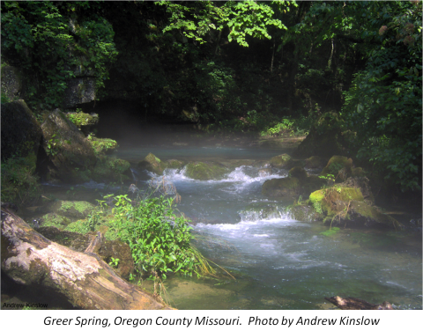
Major Themes for the Unit
- Scientific themes: Ecological Interactions, Climate Change, Nutrient Cycling, Water Cycling
- Scientific practices: modeling & argumentation
- SSI: Construction of groundwater based ethanol plant
- First-hand exploration of scientific themes via field trips

Driving Question:

Primary: Should a groundwater based ethanol plant be built in our community?

Concepts needed to explore the driving question
- Science concepts
  - Water Cycling
  - Nutrient Cycling
  - Ecological Interactions
  - Energy flow

- What social ideas and concerns influence negotiation of the issue?
  - Economics
  - Politics
  - Energy Production and Consumption
  - Alternative Energy Sources
  - Planning & Zoning

Unit-level performance expectations
- Construct and revise an explanation based on evidence for how carbon, hydrogen, and oxygen from the starches in corn may combine with other elements to form ethanol for use as biofuel in commercial ethanol plants. (NGSS HS-LS1-6).
- Evaluate stream health based on abiotic and biotic factors. Construct and revise explanations using evidence for the factors affecting biodiversity and populations in an aquatic environment. (NGSS HS-LS2-2).
- Use an ecosystem model to explain water cycling in a karst ecosystem. (NGSS HS-LS2-3).
- Use an ecosystem model to make predictions regarding the stability/change of populations within a particular ecosystem in response to changes in water cycling. Engage in argumentation about the relative stability/change of an ecosystem (NGSS HS-LS2-6).
- Obtain, evaluate and communicate information about the impacts of a groundwater based commercial ethanol plant on a karst ecosystem. Engage in argumentation regarding appropriate responses to this situation (NGSS HS-LS2-7, NGSS HS-LS4-5).
Unit assessment(s)
- Practice quizzes- two short quizzes throughout the unit
- Reflection Journals
- Models- Water cycling models produced throughout the unit
- Culminating Project- model and explanation to make sense of the likely impacts of the impacts of a groundwater based commercial ethanol plant on a karst ecosystem. Policy Recommendation to local city government regarding ethanol plant proposal.
- Unit Test- 25 multiple choice and short answer questions
Lesson Outline
I. Introduction to hydrology
Modeling as a scientific practice
Media Literacy activity
Pre unit modeling of water cycling showing human connections
Field trip to test well, spring, cattle confinement lot
II. Introduction to water quality monitoring
Water chemistry indicators
Biotic indicators
Venier Probeware sampling tools
Stream Health spreadsheet assessment
What does all of this mean?
III. Hydrology Field Trip
Ozark Underground Laboratory & Water Quality Monitoring
Surface Tour
Karst Topography
Cave Tour
Bat Flight
* Alternate venues/speaker: Local university geologist, Commercial cave tour, Department of Natural Resources specialist, Missouri Department of Conservation specialist, DIY cave tour, or other local that fits local context.
IV. What is a watershed?
Watershed modeling lab activity
Model my Watershed website activity
Mid-unit modeling of water cycling showing human connections
V. Bird Banding Field Trip
* Alternate venues: Missouri River Bird Observatory, Riverlands Migratory Bird Local university ornithologist, Local Audubon birding chapter, Missouri Department of Conservation specialist
VI. Optional 2nd hydrology Field Trip
* Alternate venues: (pick a different option than lesson 3) Local university geologist, Commercial cave tour, Department of Natural Resources specialist, Missouri Department of Conservation specialist, DIY cave tour
VII. Ethanol & Karst
Ethanol production exploration
Stakeholder Panel Discussion
Students divided into three groups. Research and present position statement for:
City Councilperson
Farmer leasing land to Ethanol corp
Family with water well next door to Ethanol plant
Discussion about other stakeholders and extra groups as needed.
*Alternate activity – guest speakers from each stakeholder group
VIII. Wastewater treatment & Water Quality Monitoring
IX. Summary
Post Unit modeling
Summative position paper
Presentation of findings to parents, school administration, city officials.

Instructional Sequences

Acknowledgments
The materials associated with the Karst Connection unit are based upon work The Missouri Transect, a National Science Foundation EPSCoR Program, Cooperative Agreement IIA-1355406. Any opinions, findings, and conclusions or recommendations expressed in this material are those of the author(s) and do not necessarily reflect the views of the National Science Foundation. The student learning logs featured throughout the unit are adapted from the organization for Advancement Via Individual Determination (AVID.org). The water quality monitoring materials presented throughout the unit are based on protocols established by the Missouri Stream Team, a project of the Missouri Department of Conservation and Missouri Department of Natural Resources. Lesson four features the WikiWatershed designed by Stroud™ Water Research Center. Lesson three & eight feature reference material by Dr. Stephen Overmann with Southeast Missouri State University and Bob Schultheis with the Missouri Extension Service.

