Introduction
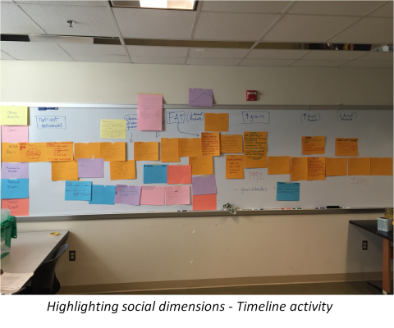
Major Themes for the Unit
- Scientific Themes: Science Themes: General Nutrition, Biochemical Pathways, Energy Systems in Sport
- Scientific Practice(s): Constructing Explanations, Engaging in Argumentation from Evidence
- SSI: “Fat Tax” (taxation of food deemed to be obesogenic, based on their macronutrient profile and/or ingredients)
- First-hand exploration of scientific themes and synthesis of related societal dimensions through analysis of significant historical and current events
Driving (Unit) Question: Should the U.S. consider implementing a "fat tax" on non-nutritious foods to discourage people from unhealthful nutrition choices?
Concepts needed to explore the driving question:
- Science concepts:
  - Macronutrients as energy sources
  - Chemical structure and function of macro- and micronutrients
  - Carbohydrate & fat metabolism: pathways and hormonal regulation
  - Nutrition and energy systems in athletic performance
- Societal dimensions:
  - Socioeconomic disparity, food deserts
  - Conflicts among economic ideologies
  - Conflicts among political ideologies
  - Healthcare regulation
  - Political motives influencing government recommendations
  - Uncertainty & disagreement in “new” and complex science field
Unit-level performance expectations
- Construct and revise an explanation based on evidence for how carbon, hydrogen, and oxygen from sugar molecules may combine with other elements to form amino acids and/or other large carbon-based molecules (HS-LS1-6).
- Use a model to illustrate that cellular respiration is a chemical process whereby the bonds of food molecules and oxygen molecules are broken and the bonds in new compounds are formed resulting in a net transfer of energy (HS-LS1-7).
- (All Sports, Exercise, and Health Science Core Syllabus Assessment Statements, International Baccalaureate Organization) *link to PDF
Unit Assessment(s)
- Daily Starter Question (revisiting Essential Science Question)
- 3-Day Food Diary: documentation and stepwise analysis of own dietary intake
  - macronutrient content analysis & related energy calculations
  - micronutrient content analysis
  - tracing of fat & carbohydrate metabolic pathways
  - comparison to current and historical nutrition recommendations
- Culminating Event: position paper on proposed Fat Tax
Overall Instructional Sequence
Acknowledgements
The materials associated with the Nutrition unit are based upon work The Missouri Transect, a National Science Foundation EPSCoR Program, Cooperative Agreement IIA-1355406. Any opinions, findings, and conclusions or recommendations expressed in this material are those of the author(s) and do not necessarily reflect the views of the National Science Foundation.​

