Introduction
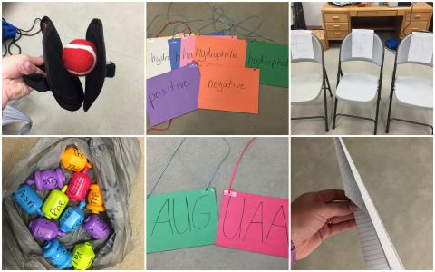
Major Themes for the Unit
- Scientific themes: Protein Synthesis: transcription, translation, protein folding
- Scientific practice: Computational Thinking, Modeling
- Cross-cutting Concepts: Structure and Function, Patterns, Cause and Effect
- SSI: Alzheimer’s Disease and Genetic Testing

Driving Question: Should the genetic tests for determining Alzheimer's disease risk be available to the public? Should health insurance companies be allowed to require their clients to take the Alzheimer’s test?

Concepts needed to explore the driving question
- Science concepts
  - Structure of DNA
  - Transcription
  - Translation
  - Protein Folding
  - Environmental Impacts
  - Genetic mutations
- What social ideas and concerns influence negotiation of the issue?
  - Insurance
  - Politics
  - Economic Status

Unit-level performance expectations
HS-LS1-1 | STANDARD / PE: Construct an explanation based on evidence for how the structure of DNA determines the structure of proteins which carry out the essential functions of life through systems of specialized cells.  ASSESSMENT BOUNDARY: Assessment does not include identification of specific cell or tissue types, whole body systems, specific protein structures and functions, or the biochemistry of protein synthesis.
HS-LS3-2 | STANDARD / PE: Make and defend a claim based on evidence that inheritable genetic variations may result from: (1) new genetic combinations through meiosis, (2) viable errors occurring during replication, and/or (3) mutations caused by environmental factors.  CLARIFICATION STATEMENT: Emphasis is on using data to support arguments for the way variation occurs.  ASSESSMENT BOUNDARY: Assessment does not include the phases of meiosis or the biochemical mechanism of specific steps in the process.
Social Connections | Students will analyze and interpret data and use evidence driven argumentation to describe the effects of either side of the issue of insurance and genetic testing for Alzheimer’s disease.
Unit assessment(s)
●Models and algorithms
●Culminating Activity
●Content pre and post exam- multiple choice and short answer

**The unit references a practitioner article that will be published in the American Biology Teacher journal. Contact Mandy Peel at anpn98@mail.missouri.edu for an electronic copy of the article.

