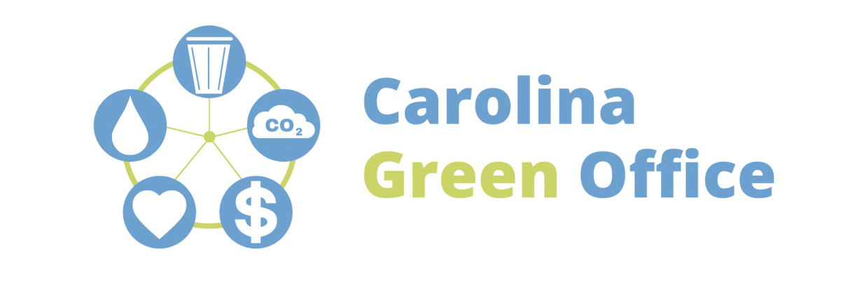

Outside of being aware of water usage, paying attention to stormwater quality is one of the easiest and most important ways of helping preserve earth’s water. In urban areas, stormwater is likely to run off more quickly and in greater volume into nearby waterways, bringing with it oils and grease, metals, chemicals, cigarette butts, bacteria, and more. Being aware of this issue can help us make campus more beautiful and healthy!

What you may see
When looking at stormwater drains or runoff streams near you, here are some things to look out for that may indicate stormwater contaminants:
- Soap and suds
- Odd colored water
- Out of place odors (especially ones smelling like sewage or chemicals)

In addition, keep an eye out for any debris blocking drain or drain paths as well as flooding. Both are signs of stormwater drainage issues that you can easily see and report!

Learn more about how you can help
For more information regarding stormwater contaminant causes, impacts, and indicators: https://ehs.unc.edu/topics/stormwater/education/
To report a stormwater containment or drain blockage problem on campus: https://ehs.unc.edu/topics/stormwater/report-a-problem/

