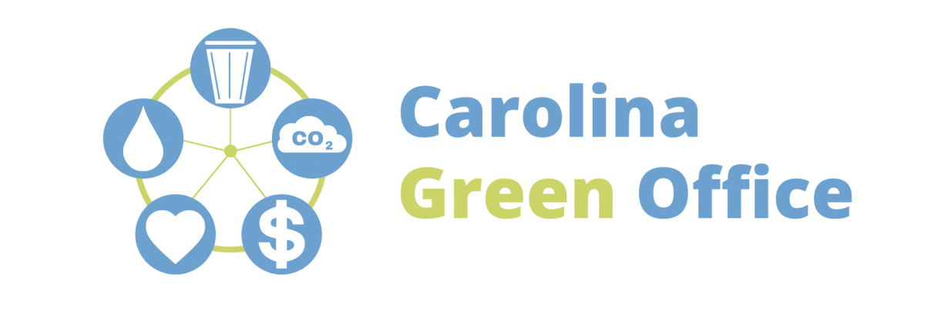

Before we leave for break, there are a few easy steps we all can take to power down the office. Each task only takes a few seconds, but these small energy-saving actions can have a major impact on costs, efficiency, and sustainability!

Here is a quick checklist to look out for before you head out:

- Turn off computers
- Unplug power strips
- Unplug appliances and non-essential equipment
- Shut windows and blinds
- Adjust the thermostat (to 65 degrees Fahrenheit or less during heating months and 82 degrees Fahrenheit or higher during cooling months)
- Turn off all lights

We appreciate everyone's help reducing our energy consumption and making this office more sustainable!

