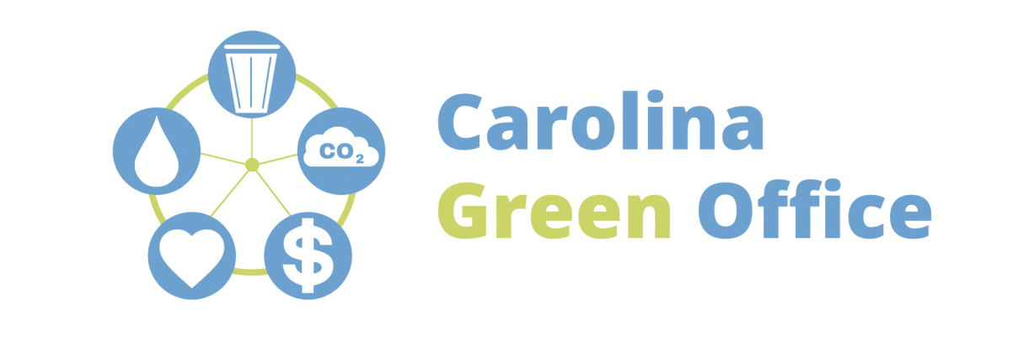

One of the best ways to be sustainable is by recognizing the waste we produce and decreasing the need for single use items. In the US, about 25 billion takeaway cups are thrown away annually. Many of the materials like plastic and styrofoam your everyday throw away coffee cups are made to take hundreds of years to break down, not to mention the environmental impact of producing cups at such high volumes.

While recycling is a helpful tool for keeping waste out of landfills or the environment, cutting waste at the source has a much more significant effect on our everyday costs and the overall wellbeing of earth. When thinking of simple sustainability swaps, the first and potentially most impactful step is to reduce waste.

Mug Share Program
We're asking everyone to bring in a mug or two to help kick off our mug sharing program, working to minimize our office waste as much as possible. Mug sharing is an easy, fun, and sustainable way to improve our office! Please bring your mug to [INSERT KITCHEN, DINING AREA, ETC] to help reduce our single use material waste!

Following the success of our mug share program, we want to expand the ways our office can limit packaging waste! This includes any single use utensils and dishes that may seem convenient, but significantly harm ecosystems, human health, and are much less cost effective.

Each year, Americans use about 561 billion single use utensils. Again, while recycling is extremely important, only about 9% of plastic items end up being recycled. Reducing waste by saying no to single use and repeatedly using the same untencils/dishes offers a sure method of reducing the plastic, paper, and styrofoam in our environmental systems and landfills.

Utencil and Dishes Share Program
Like with the mug share program, we enocurage anyoneto bring reusable utensils or plates to the office to add to our sharing collection. This will help us reduce our overall waste footprint and maybe save you money in the longrun! Please bring any utensils or dishes you wish to share to [INSERT KITCHEN, DINING AREA, ETC] to help us reduce our single use material waste!

